MY EXPERIENCE AT: National Computer Science Summer School

AKA: The event that changed my life🎉

OKAY SO a few housekeeping things:

First of all, WELCOME TO MY NEW BLOG 🎉🎉🎉🎉🎉🎉, thinkaboutit.space is going to be a space where I aim to share my experiences with the world, interesting projects that I work on, and write articles about the intriguing nature of humanity. The posts will vary in style, some being stream of consciousness, some being serious , some being serious, past/present experiences, some being full of dank memes, and some just being me nerd speaking about what I love.

It’s also important to note that as I write this, the website is still under construction, and blogging + building a website from scratch + HSC + 2 jobs + school is a very hard balance so PLEASE be patient. If you wish to contact me for any reason, you can easily reach me at [shrey.somaiya@gmail.com (i](mailto:shrey.somaiya@gmail.com%20%20(i) check my email like every minute I swear)

OKAY NOW ONTO THE REAL POST

This post is going to be an informal recount (on the WEB stream of NCSS) followed by a stream of consciousness (omgthankyoueveryoneiloveyou) segment, followed by my final remarks about NCSS( Why it is such a great program, what would I change, and why I think everyone should be encouraged to go).

TABLE OF CONTENTS:

Recap:

* Day 1
* Day 2
* Day 3
* Day 4
* Day 5
* Day 6
* Day 7
* Day 8
* Day 9
* Day 10

Thoughts

* Appreciation
* Final Remarks

# PROLOGUE: En Cee What now??

I have to admit, I have always been in love with technology. My dad used worked in several tech companies (in Finance) and would often bring home several broken/old laptops and try and fix them. If/when he did I would often play with them (windows XP & old school snake baaybeee). In year 5 I attended a Lego Mindstorms workshop, where I got to build a lego car and program it to move back and forward. Looking back, it’s clear to me that this is when my computational thinking abilities first developed. Everyone else was figuring out how to even move the car and I had already figured out how to program the cars to move when remotes.

You know, I could spend so long on the story of how I got to NCSS(story for another time) but **TLDR**: I saw a poster in year 7, did some research, realised it was for year 10+, sulked for a few years, applied WITH EXTREME ENTHOUSIASM, was super worried because the application results were LATE and I thought I didn’t get in, then I got in!!

# DAY 1- Who what when where why

OKAY SO Day 1 was quite a mess for me, I came to this camp being the ‘tech wonder boy’ since primary school, and being quite proud of my abilities as a “háčkêr” (AKA “Have you tried turning it on and off again?”) and I thought I was quite good at what I did, and that this camp would help me with my group work rather than my technical skills (because I was obvs the best at everything duh). WOOOOOOOOAAAH boy was I wrong.

You see little did I know, I was just a fish in in this wide ocean of nerds.

Day 1 started with grabbing my keycard for my room and standing and playing on my phone in the corner (an advanced “leavemealone” technique) while my siblings ate all the free food. I was **super** excited when it came to get all our freebies I mean \***cough\*** educational assistive tools. This included stuff like our big theory booklet (~200 pages of raw coding goodies), water bottle (I lost 3 over the course of NCSS :thinking), timetable(I don’t think I ever ended up using this), name badge, and of course, our official, 100% sponsor certified NCSS shirt!!

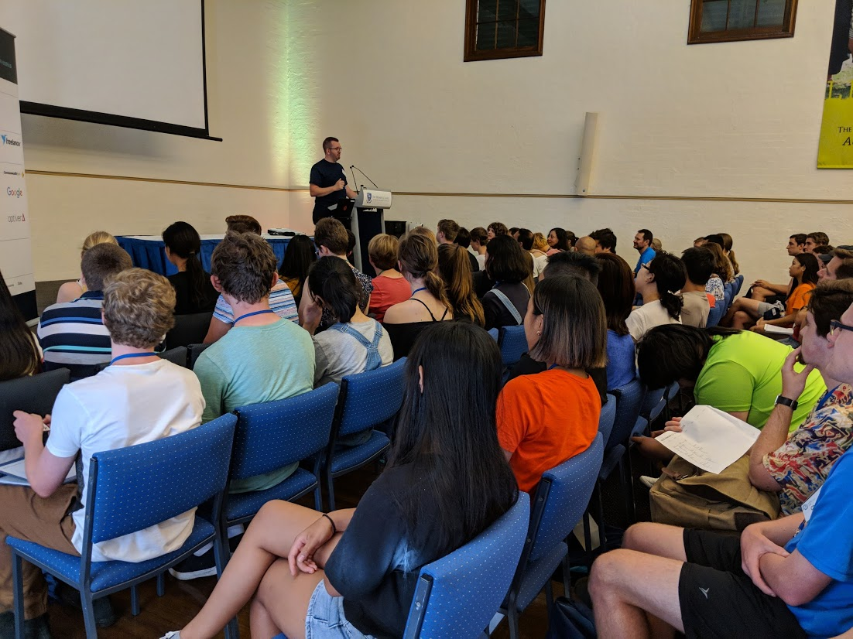After we grabbed our free stuff, we all went to sit In the main hall (Also known as **Menzies**), and we got our welcome speech in which the glorious and elaborate history of NCSS was revealed to us, followed by a few speeches from Ex-NCSS students now working at tech giants, and from the CEO of Wise-Tech himself.

As soon as the welcome speech was over, we launched straight into our first lecture, reviewing the basics of python and brushing over the use of dictionaries. I knew that this was going to be a great camp when we realised that it was dinner, and it felt like we just started the lecture.

NERDS UNITE!!

After dinner we had our first night activity, and the first chance to meet our groups and tutors. Everyone got into their groups (the groups that you would be completing all activities with, and undertaking the project with). We went outside to the front lawns and played some group building activities, such as bang, remembering what everyone bought from a shop, and seeing how many people we could fit onto a 2x.5 m bench(15 I think).

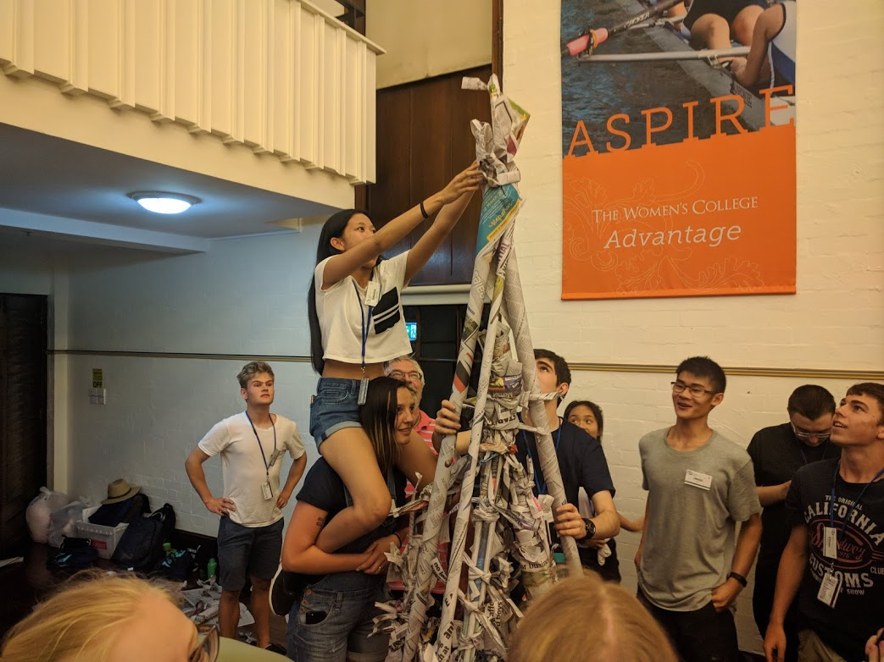

*The final touches of my groups tower*

After that we went back into Menzies, and completed a “who can build the tallest tower out of newspaper challenge” , a challenge designed to test and grow our teamwork, communication and technical abilities.

The rules were simple, each team had only newspaper and their brains to make the tallest tower possible, and each tower had to feature the #platniumsponser JB-HIFI catalogue as a flag (JB HIFI wasn’t actually a sponser, it just became a joke that they were, as every tower had to feature a JB HIFI flag).

Our design was similar to that of a tepee, and was quite unique compared to other groups, who went with a pyramid design of stacked cylindrical newspapers. We ended up coming third or fourth and we learnt the hard way that **communication was key** to group work, which would be critical in the upcoming week.

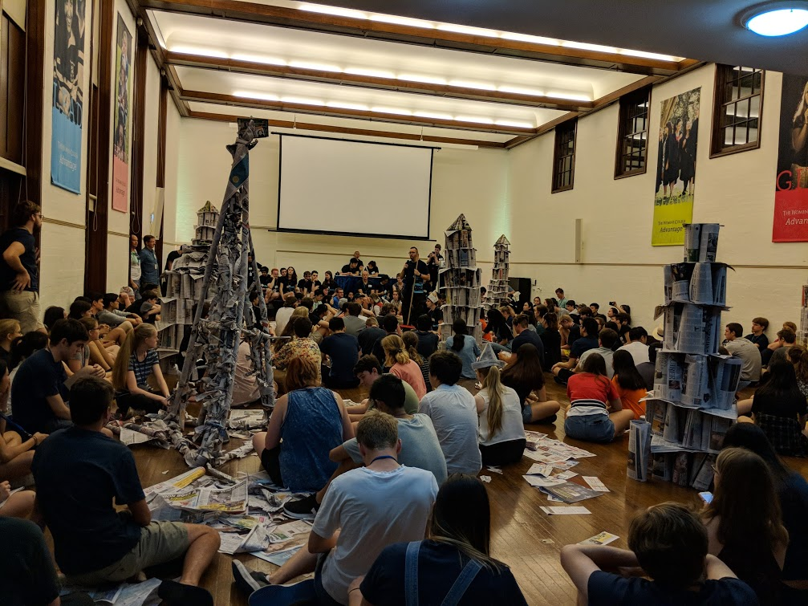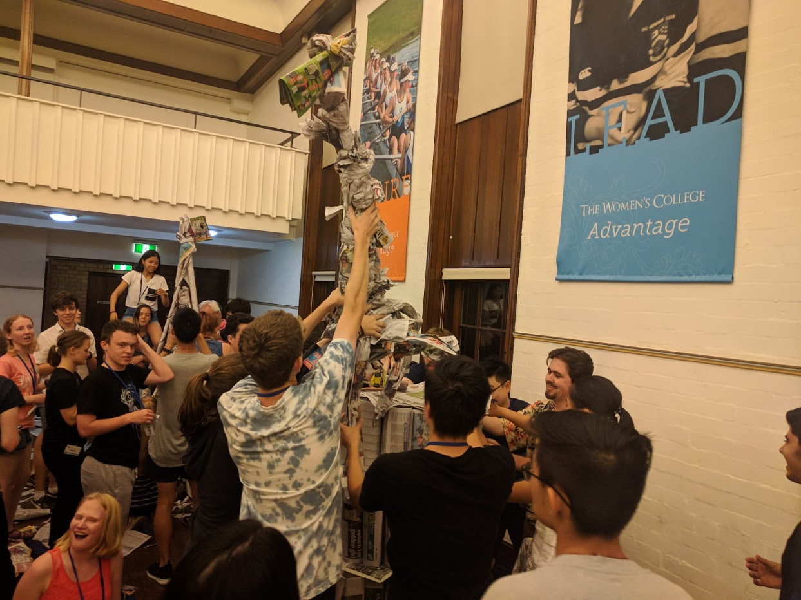

*We still don’t know what this was supposed to be…*

*A snapshot of other groups towers*

# DAY 2- First lectures at ABS & First Lab sessions(I promise the other days are smaller)

Day 2 started off with breakfast (omg so much fooooooood), roll call at Menzies, then a brisk walk to the Abercrombie Business School(ABS) where all our lectures over the course of NCSS were held. I cannot remember for the life of me what all the individual lectures were( don’t judge me guys I went to like 14), but overall as a whole, I learnt so much from them. The lectures were held on topics such as:

* Regex
* Dictionaries
* HTML & CSS
* Javascript
* SQL
* Templating engines
* Recursive Functions
* Object Oriented Programming
* Finite State Automata & Determinisation
* Context Free Grammars
* Parsing

After our lecture, we then went to the School of IT’s computer labs, where we worked on solving problems (via programming obviously) relating to the previous lab session.

Three hours quickly passed by and we walked back to the Womens Collage for lunch. At 1:45 we left Womens again to do another Lecture + Lab session.

TRIVIA

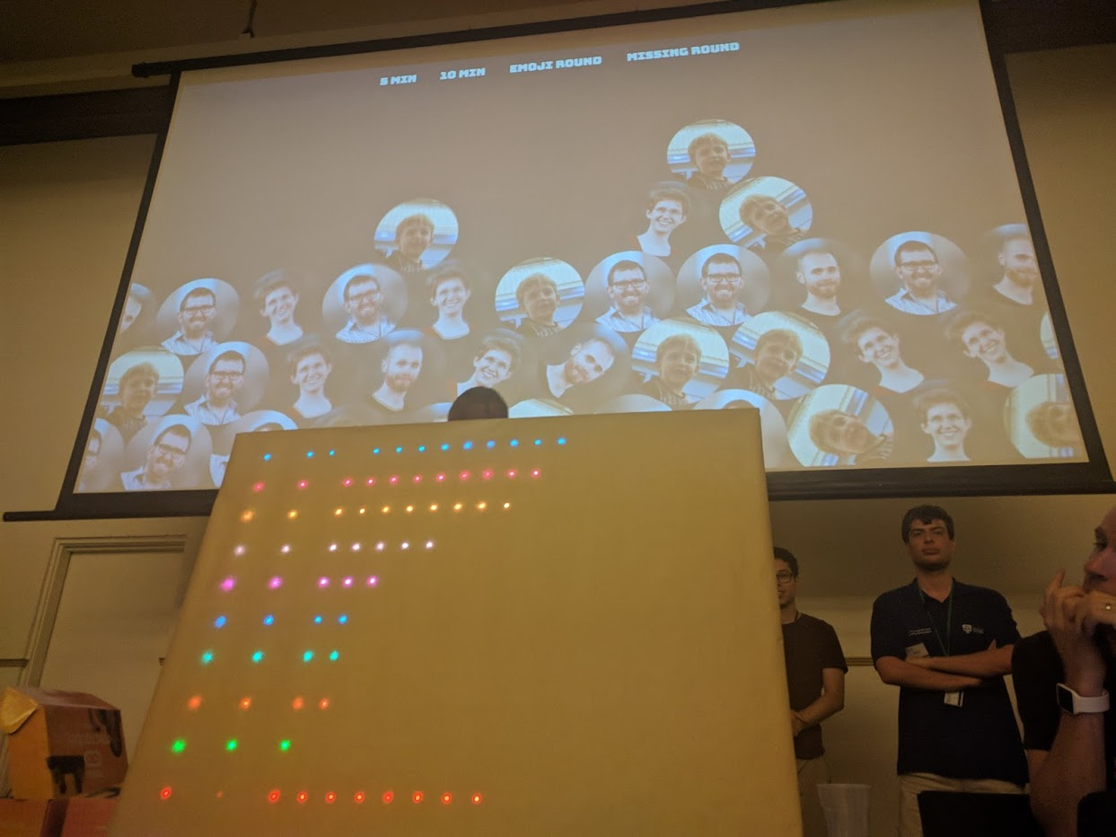

The night activity , as you astute readers already know from the snazzy title above, was trivia!

However, this was no ORDINARY trivia, no nonononono, this was a nerd trivia of the HIGHEST integrity which featured our own SELF UPDATING scoreboard using the power of TECHNOLOGY, as well as a tutor-made trivia website with tutor icons dropping everywhere (as seen in the picture to the right).

The trivia rounds consisted of the games **Name that emoji**, **general geek trivia**, **connections**- a word puzzle game, **What’s missing in this picture** and last but not least, the “**NCSS charades conga line spectacular**”!

In case you’re wondering what the heck that is, it’s basically an elite mixture of charades and Chinese whispers. Each team would stand in two lines, with everyone except two designated actors would face away from the screen. A movie title would be displayed on the screen, and the two designated actors would try and convey the movie title to the person behind them. The first actors would turn around and the person behind them would try and convey the acting onto the next person, and so on, and so forth until it reached the end of 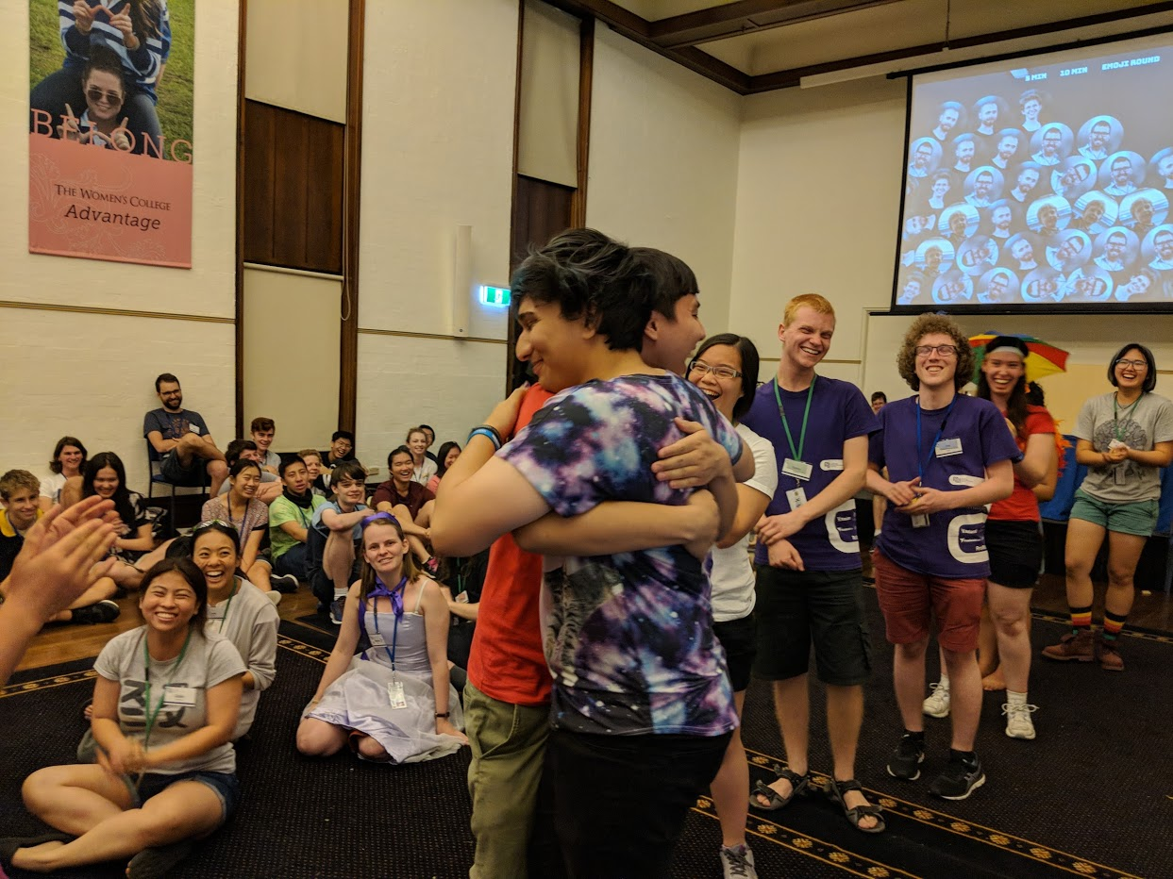the line, by which point the original actions had been so misportrayed that the original meaning was completely lost. The trivia host ( The hacker known as “Alex” ) would then give each team member a guess at what the movie was(Fun fact this accidentally ended up in a marriage at some point)

*“Will you marry me?”*

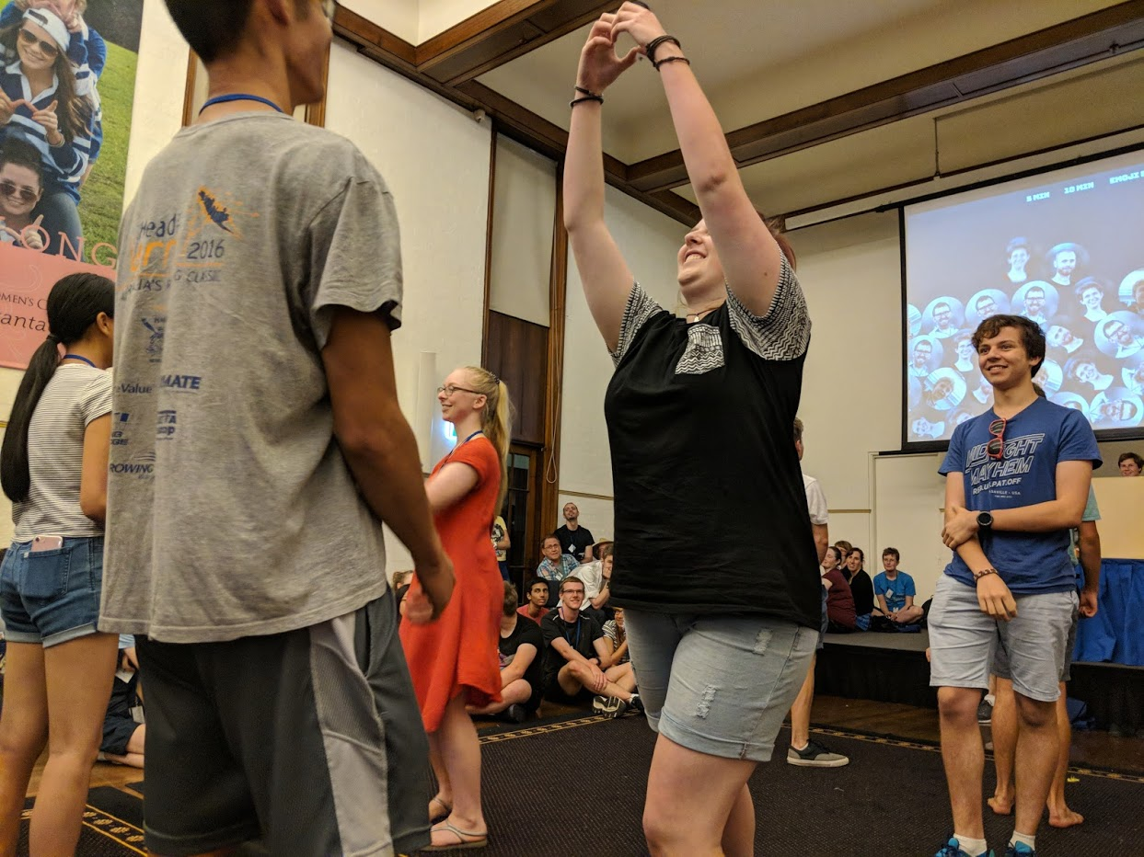My team was the 5th team to go, and by that time we had established that a majority of the movie titles were Disney based, so a team member proposed a system- if the movie was Disney we’d point to our knee ( DIS KNEEE) , and if it was Disney and animation, we’d make a circle on our knee. When it got to our turn, our system helped heaps, and not to mention we got the lion king, one of the easiest to portray ( we got it on the first guess!!! WHAT TEAM!!)

I think this activity was really good, as it relied heavily on the integration of problem solving and communication. This was clearly shown when our team followed a system to make our charades more efficient and easier to guess what the movie was.

# DAY 3- SCAV HUNT

Day 3 consisted of our usual lecture-lab-lecture-lab format, and since I already talked heaps about labs and lectures, we can just skip righttt over that. The night activity for the Sunday was the Scavenger hunt, in which our team came SECOND WOOO TEAMMMM. Our team split into two mini teams, one who wanted to try hard and run, and one who didn’t want to run nonstop. There were 5 activity stations, and dozens of photo opportunities and signs to write down. We ended up running through the university of Sydney for a good ~3 hours, which gave us plenty of time to admire the beautiful campus and the many different facilities it had to offer. The scav hunt also provided an insight into the student culture at USyd, provided by our tutors (one of whom was a USyd graduate), as they pointed places that were popular for studying or coffee etc.

The reason I liked the scav hunt was because it provided an opportunity to bond with my teammates and gain insight into the culture/campus of USyd whilst also actively practicing the communication and problem solving needed to calculate the quickest route to all activities.

# Day 4- Games night/Free time

Now technically, the night activity was “free time”, which consisted of sleeping for a majority of students, teachers and tutors alike, but I decided to hang out in the library and play board games with the tutors and my fellow peers.

It was that night that I was introduced to the fast paced game of observation and reflexes, Jungle Speed. The students had such a passion for this game, that it often ended up in fast grabs and wrestling for the totem. I REALLY liked this game, in order to win you had to rely on nothing but your eyesight and reflexes, which was a refreshing break from problem solving nature of previous nights. I also got to play mafia (a group role playing game of strategy, survival, and the ability to spot a fraud.), with an awesome tutors (you know who you are) as our host. I loved games night, as it provided a non-computing opportunity for me to bond with both students and tutors alike. It became a foundation for the great student-tutor relationship that NCSS offers.